Name | ID
Tamim Rafi Ahmed | 2021-3-60-089
Md. Sakib husen | 2022-1-60-274
Mahadi Haaan | 2021-3-60-270
Md Moynul Haque Tuhin | 2021-1-60-062

Task 2

Evaluation | Mobilenet-v3 | Efficientnet-v2 | resnet50
Report Accuracy | 15.83% | 72% | 3%
Class Accuracy
Precision | Macro avg: 0.03  weighted average:0.08 | Macro avg: 0.03  weighted average:0.08 | Macro avg: 0.0  weighted average:0.0
Recall | Macro avg: 0.06  weighted average:0.16 | Macro avg: 0.06  weighted average:0.16 | Macro avg: 0.02  weighted average:0.03
F1-score | Macro avg: 0.04  weighted average:0.10 | Macro avg: 0.04  weighted average:0.10 | Macro avg: 0.00  weighted average:0.00
Confusion Matrix | 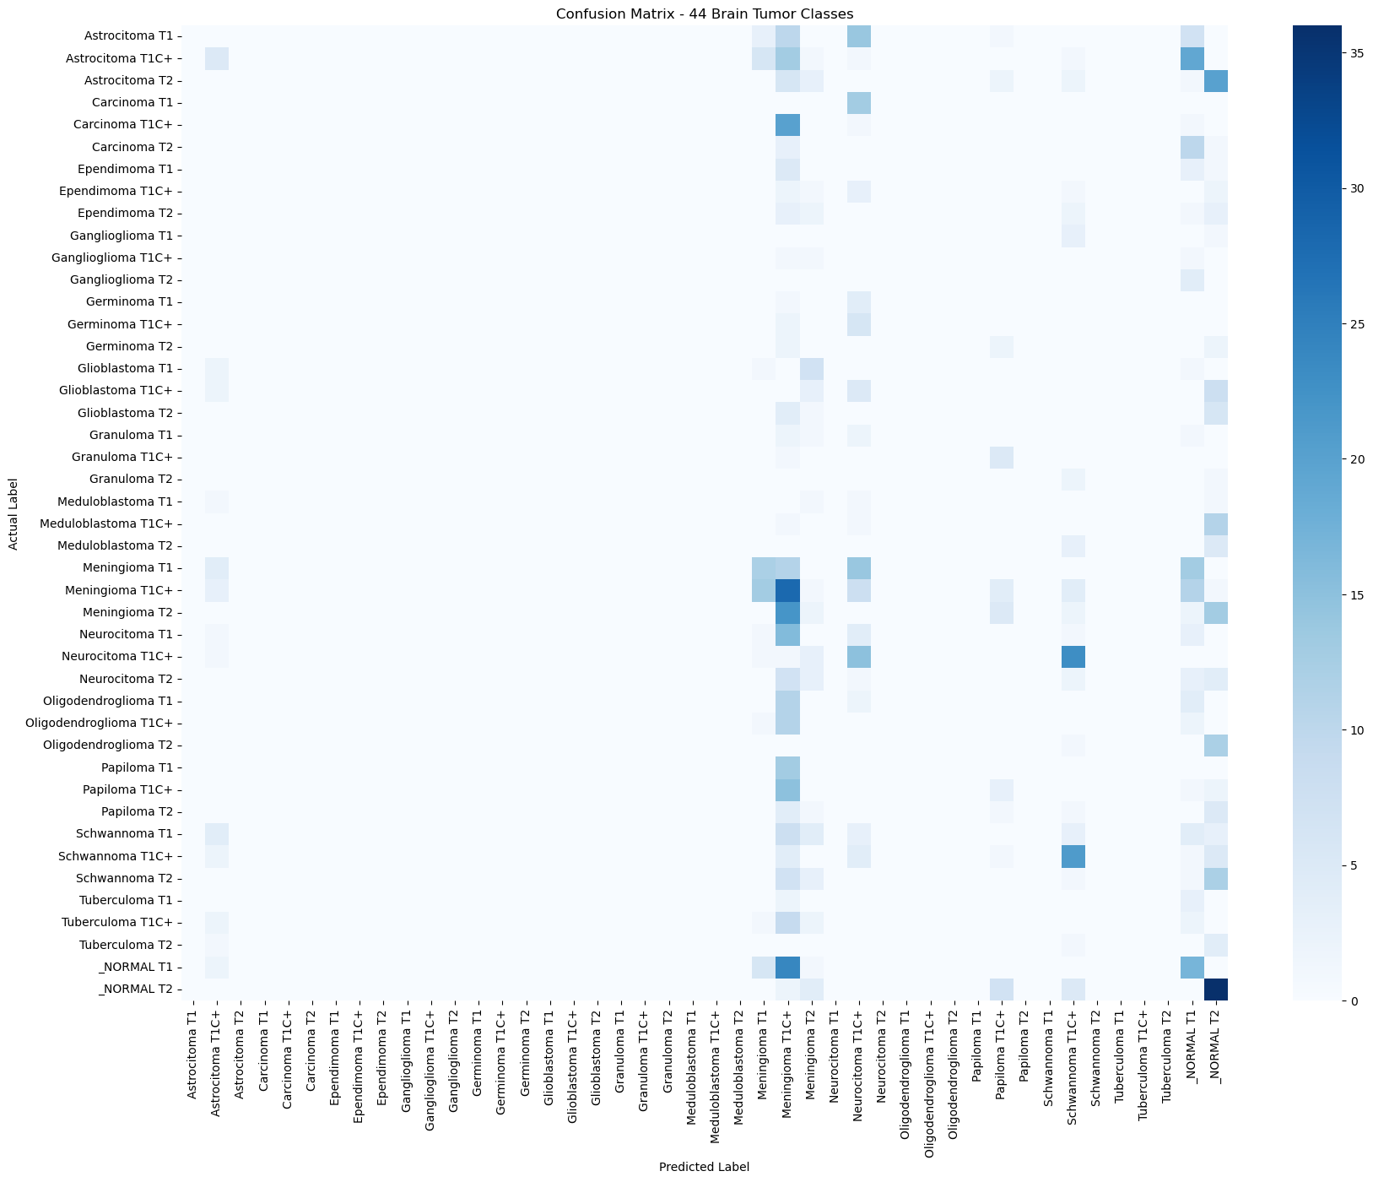 | 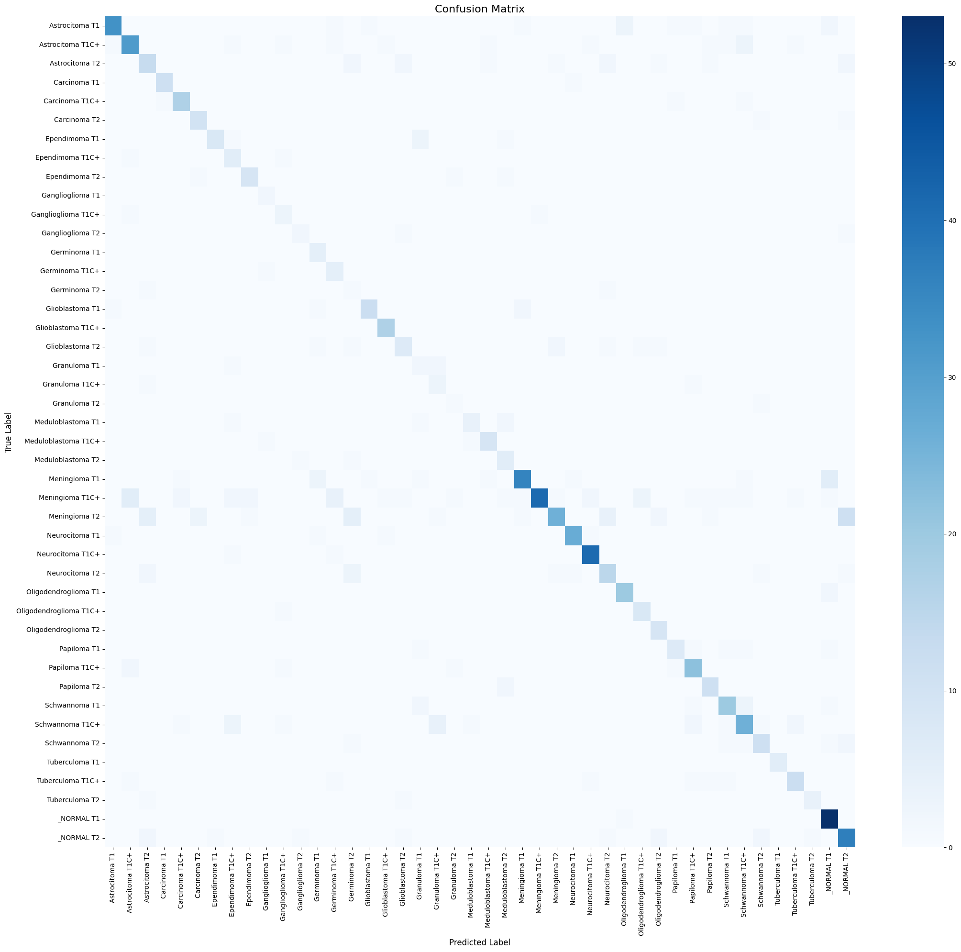 | 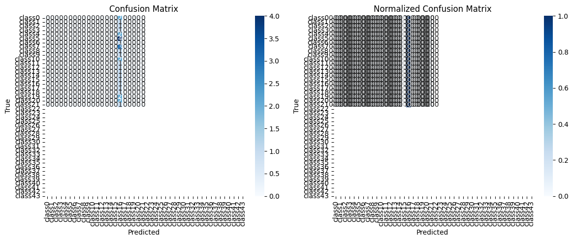
AUC score  (macro-averaged) | 0.7266 | 0.9844
ROC curve | 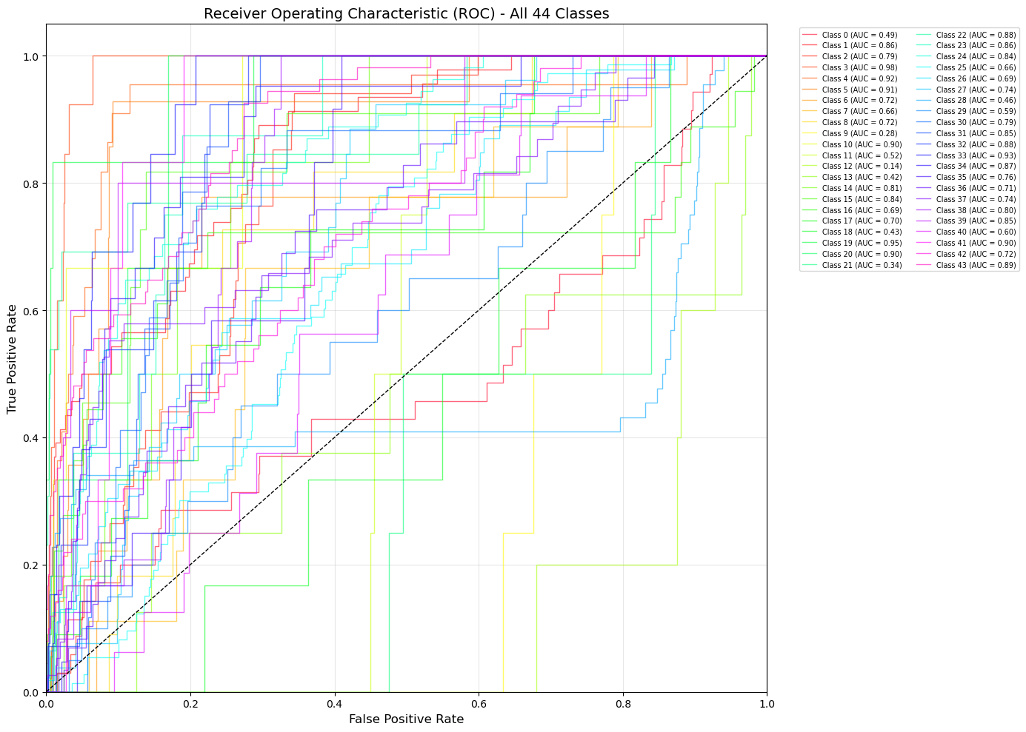 | 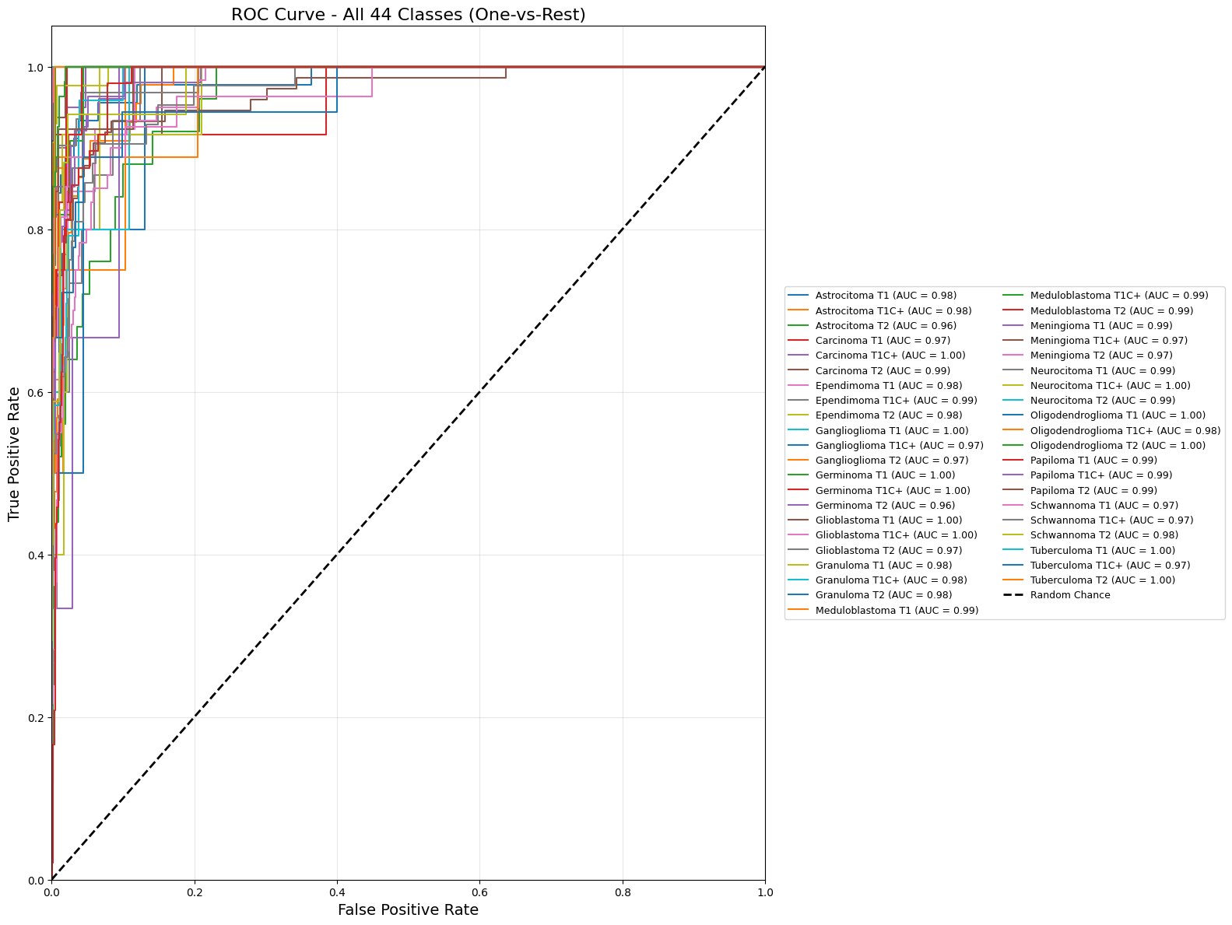
Training time | Total Training Time: 36m | Total Training Time: 15m 19s | 5.15 m
testing time | 9.86 seconds | 3.84 seconds
paired t-test | 12.0884 | 11.9431 | 8.5774
Performance | 164ms/step

